Tennessee Fire Chiefs Association

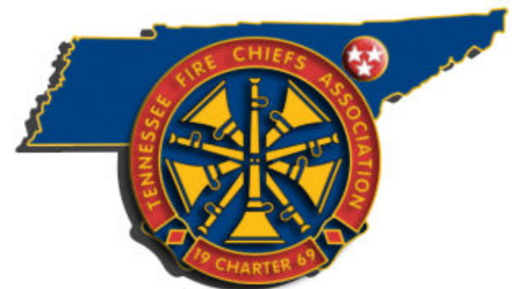

MAKE YOUR PLANS NOW TO JOIN US FOR THE
TFCA Fall Quarterly Meeting
October 21 - 23, 2026
Holiday Inn Hotel - Johnson City, TN
HOTEL RESERVATIONS
Call 1-423-282-4611
Select your room
Group Room Block Code: “JRW” rate available
Be advised we are attempting to work with the hotel to extend the room block dates and the rate to include Tuesday (10/20) night, please send email to jamesf@cityofmilantn.com if you are having any reservation issues.

Don’t miss this great training opportunity at the TFCA Quarterly Meeting. These meetings help today’s fire chiefs and tomorrow’s leaders prepare personally and their agency for progressive leadership. Meeting highlights include:
- Committee meetings on topics such as legislative issues, mutual aid, fire prevention/education, professional development, safety, and fire accreditation are just a few. Perfect opportunity for you and your agency to become involved!
- Medical CE and Leadership Training
- Excellent opportunity for professional development and networking with peers from across the state
Full agenda to be posted on the TN Fire Chiefs webpage soon at www.tnfirechiefs.com

