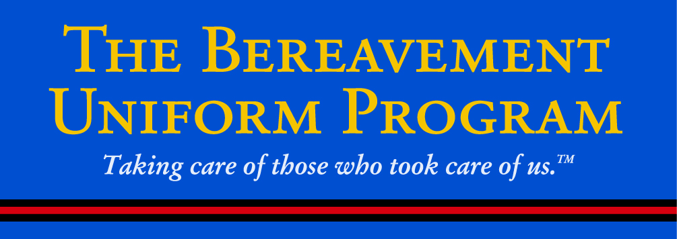

**A GIFT, NOT A PRESENT**

**BUILDING the BRIDGE of OWNERSHIP**

The Lighthouse has done its job and the Bereavement Uniform Program (BUP) is up, running and available in all 50 states.

TFCA ‘s Chief Barron Kennedy has stepped up and done his job and joined Hendersonville FD’s Chief Jamie Steele and Springfield FD’s Jimmy Hamill in donating surplus Class ‘A’s.

Now, the time has come for you and your department to step up and help make the Bereavement Uniform Program permanent and self-sustaining in Tennessee.

**If** you are from a fire department or have retired firefighters without dress uniforms you are a ‘recipient department’ and your ‘job’ is to link the BUP to your department’s website and/or Facebook page. Linking will provide program awareness, easy access, a level of anonymity and will take the ‘need to ask’ out of the equation. Hyperlink and coding was developed for the BUP by the Washington Fire Chiefs Association.

**If** you are from a department that has a Class A Dress program, you are a ‘have department’ and your job is to make sure your department and your neighboring departments with surplus dress uniforms donate them and ‘keep the TN pipeline full’

This is an opportunity to recognize the service of the men and women that call the Tennessee Fire Service ‘family’. It’s easy. It’s free. It’s right.

Email me at [steve@lighthouseuniform.com](mailto:steve@lighthouseuniform.com) to find out more.

Thank you very much.

Steve Cohen, Pres.

Lighthouse Uniform Company

In Tennessee you can contact Barron Kennedy at [bkennedy8795@gmail.com](mailto:bkennedy8795@gmail.com) or Steve Dillard at [chiefdillardmfd01@gmail.com](mailto:chiefdillardmfd01@gmail.com) for additional information. Thanks for your support.